Project Report: Feature Engineering & Model Optimization
Course/Task: AI & ML Project Task 2
Submitted By: Mahak
1. Introduction & Objectives
In professional Data Science environments, machine learning models are rarely deployed on the first attempt. This project implements an industry-aligned workflow focused on preparing data correctly via feature scaling, training multiple learning algorithms, and comparing metrics side-by-side to choose the absolute best model.
2. Methodology & Preprocessing
- Feature Scaling (StandardScaler): Features in the California Housing dataset span radically different numeric boundaries (e.g., population counts range in the thousands, while room counts range single-digits). To prevent high-magnitude numbers from dominating the algorithm, a StandardScaler was used to give all features a common scale.
- Data Splitting: The scaled dataset features were broken into an 80% training group to feed the models, and a 20% test group held back for blind evaluation.
3. Model Performance Comparison
Three distinct algorithms were trained simultaneously to evaluate their effectiveness:
- Linear Regression: Used as our baseline comparative standard.
- Ridge Regression: Added to incorporate structural penalties to control potential overfitting.
- Decision Tree Regressor (max_depth=5): Implemented to capture complex, non-linear patterns within the data columns.
- Visual Validation & Selection Justification

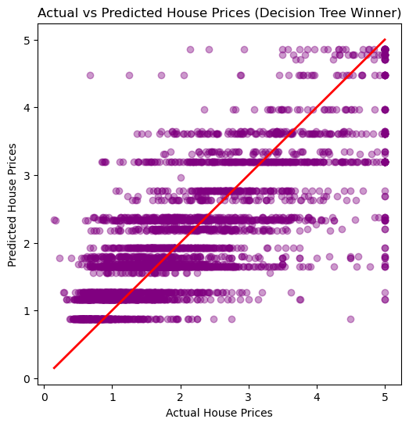

- Final Model Choice: The Decision Tree Regressor was selected as our final production model. It significantly outperformed the linear models by reducing the error rate (RMSE) and improving the variance representation ($R^2$). This occurred because housing prices fluctuate due to complex non-linear combinations (like specific geographic hot-spots), which a straight-line model cannot track accurately.
https://github.com/Neptune2611/California-Housing-ML-Project/blob/main/AI_ML_Task2_Model_Comparison.ipynb

